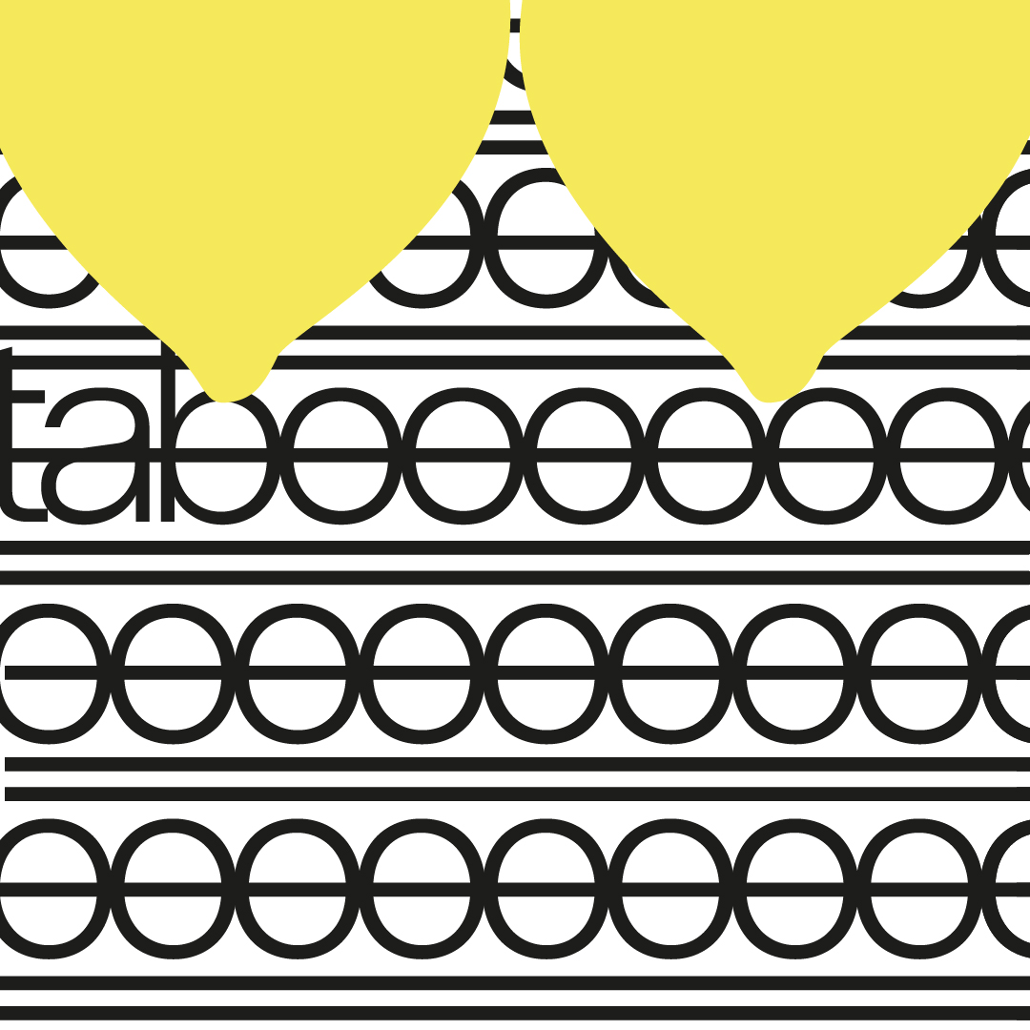

Title of your work
Name
Briefing 1 2

MODEL YOUNG PACKAGE 2026

Table of Contents

- Description of your work
- Photos of your physical prototype
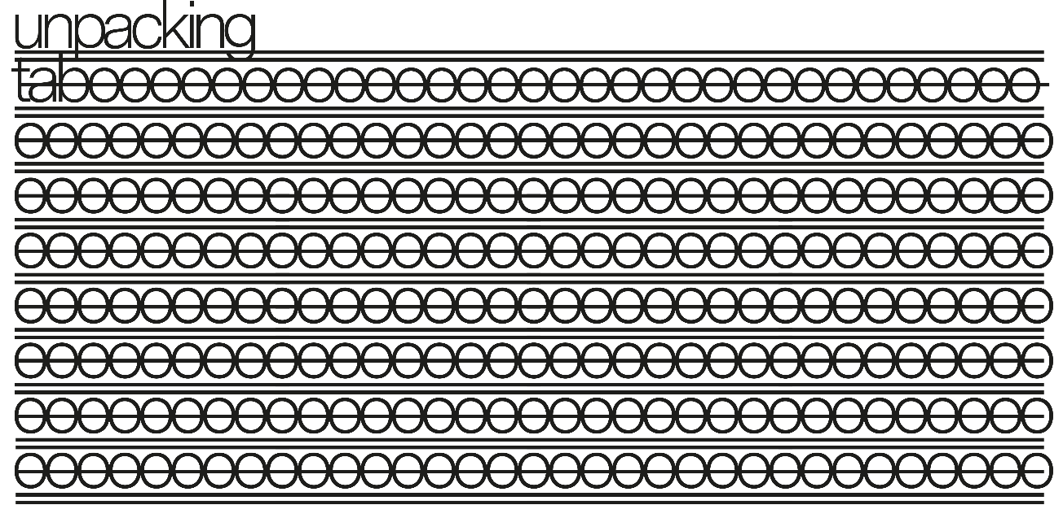
- Structural design blueprint

Description of your work

- Photos of your physical prototype
Take pictures of your physical prototype and include up to 5 pictures.
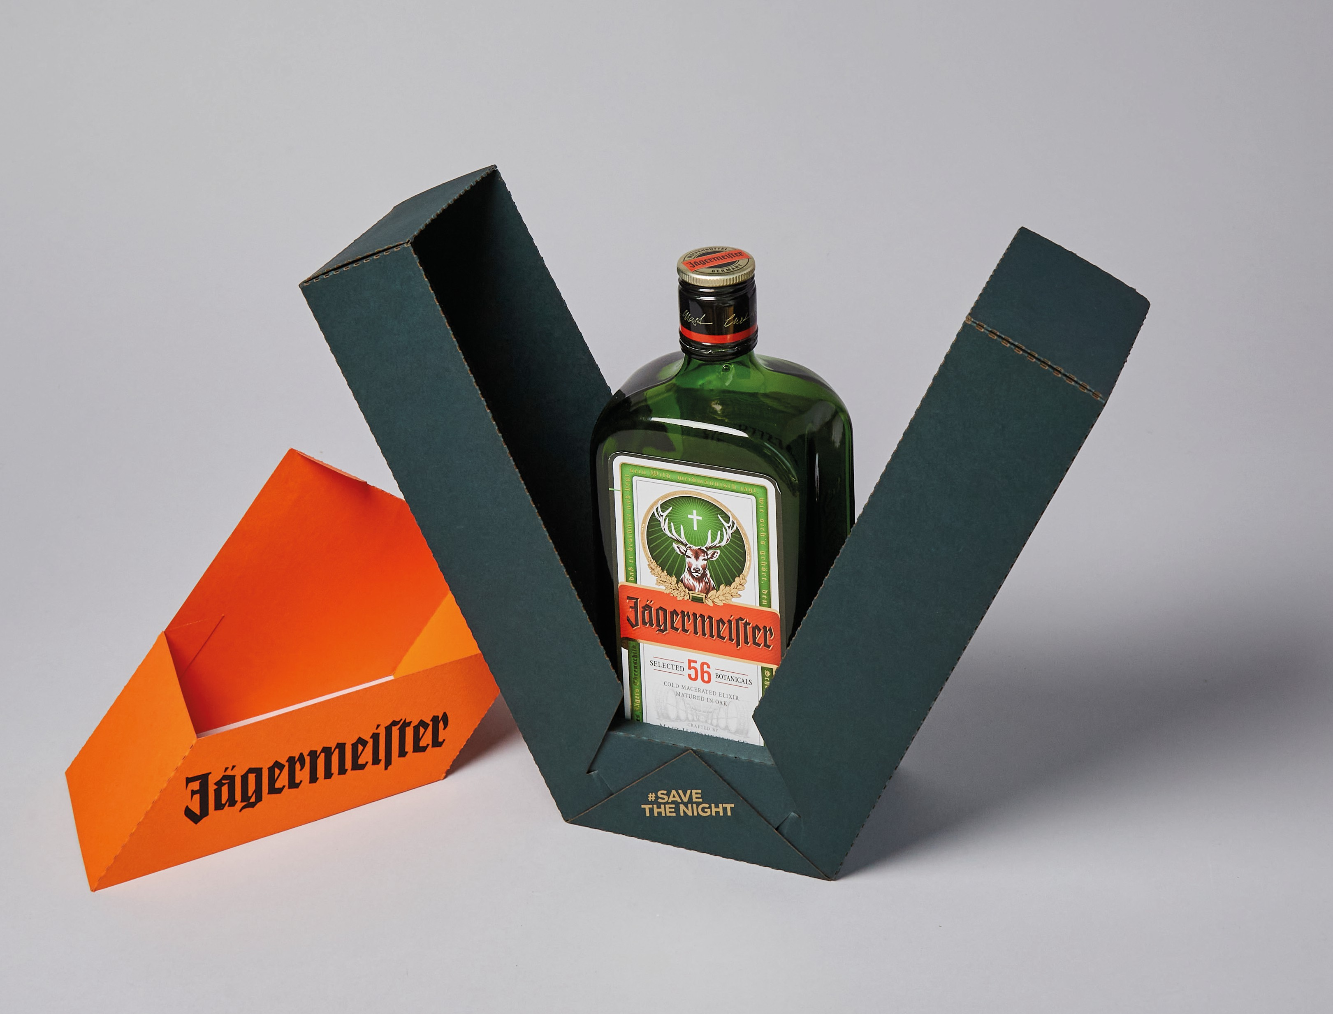
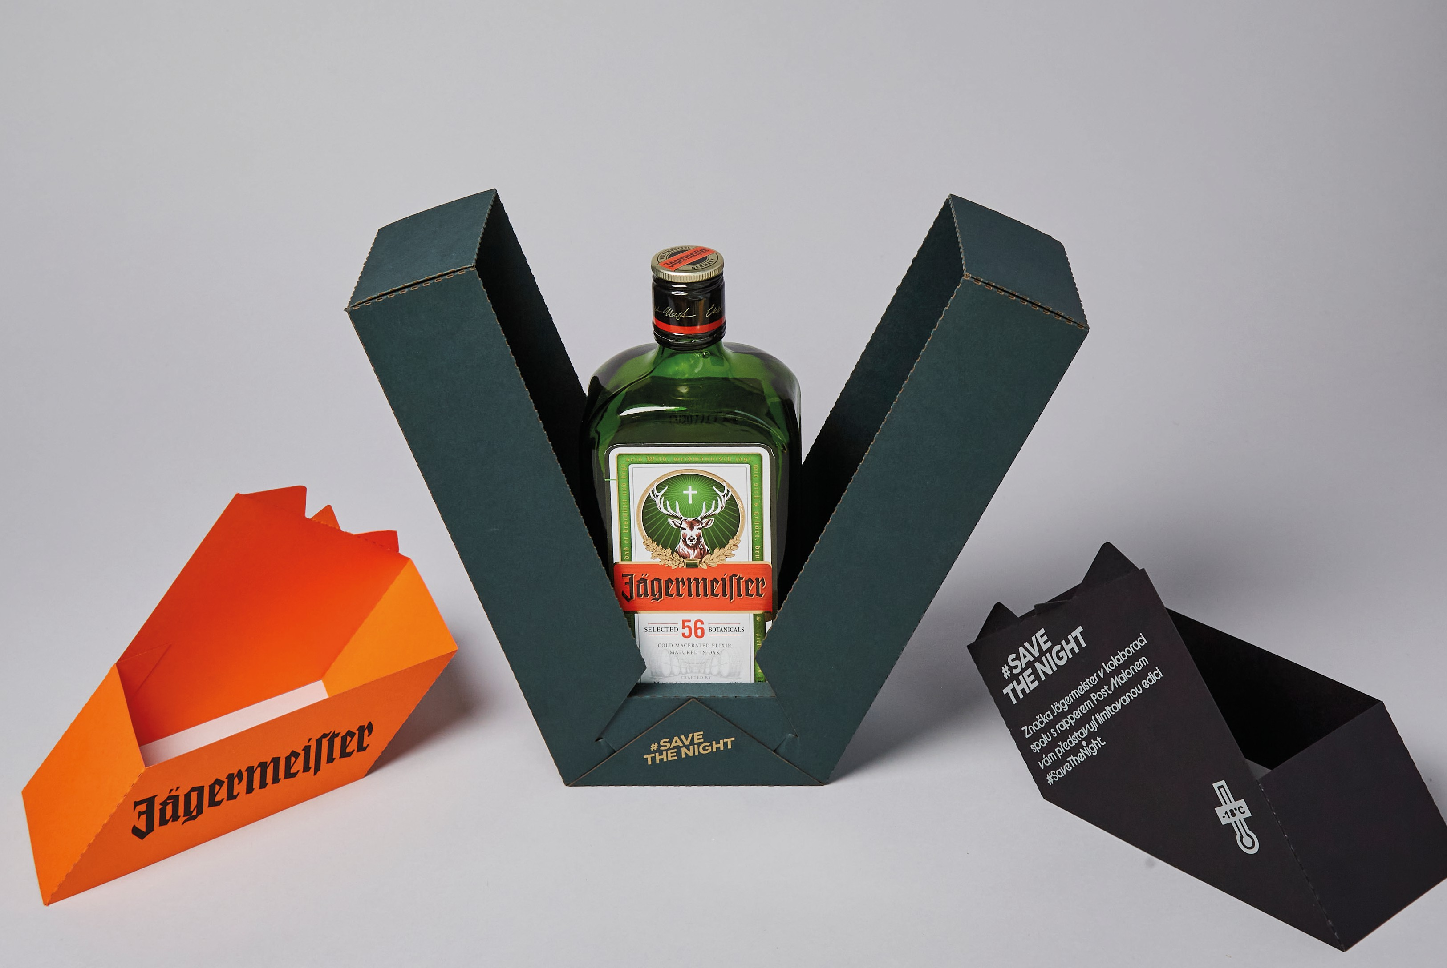
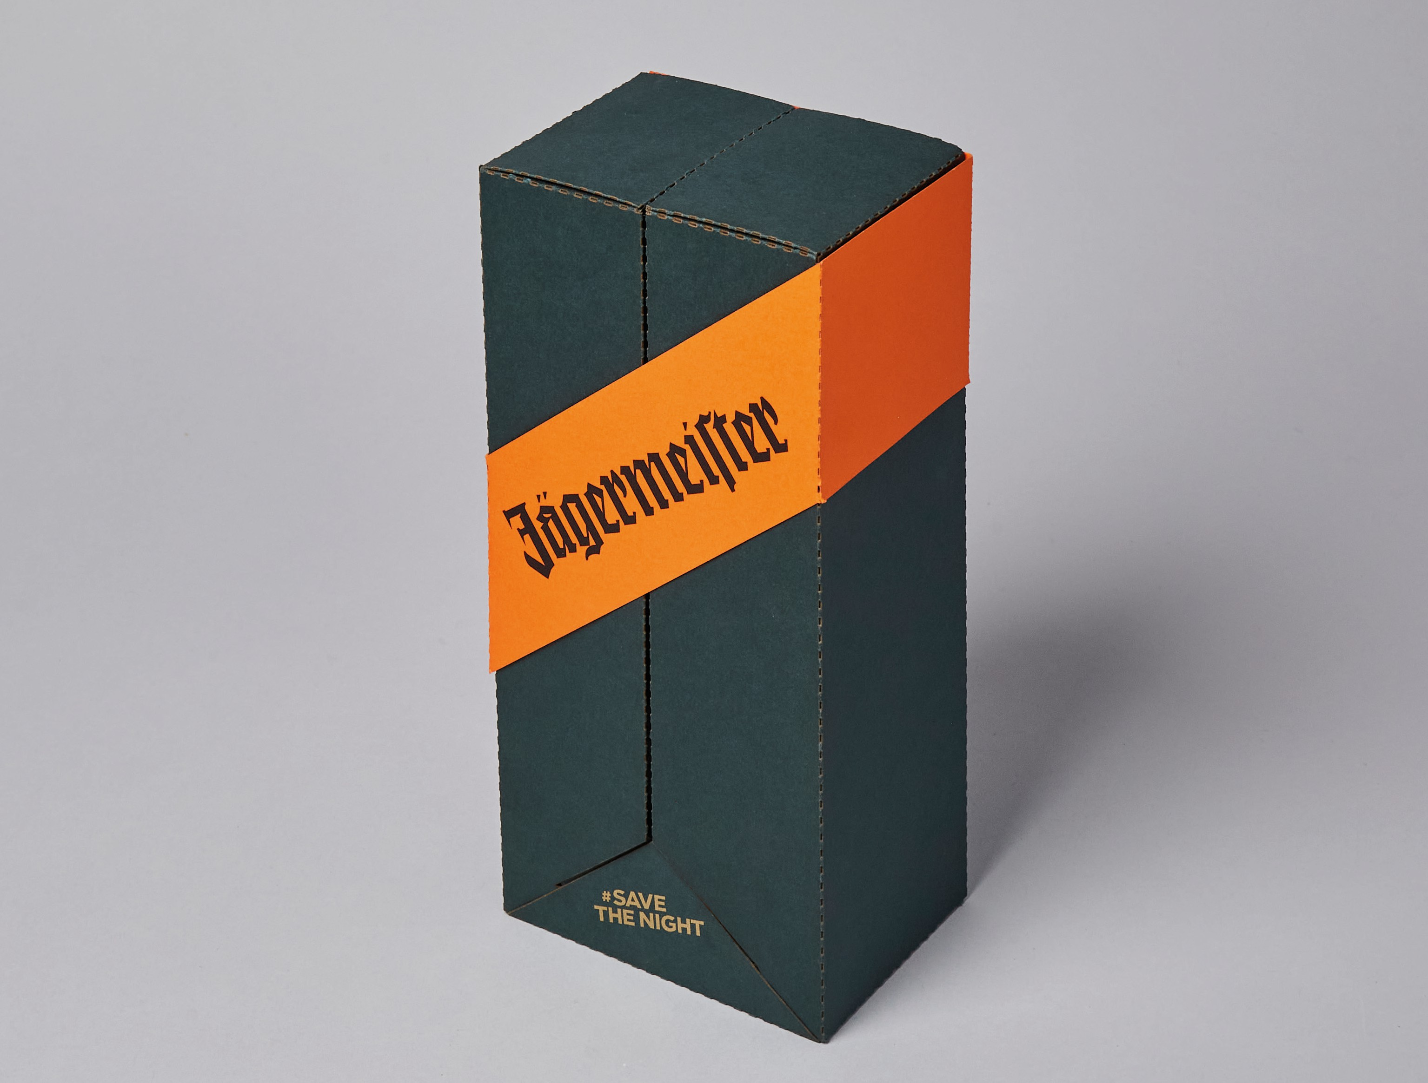
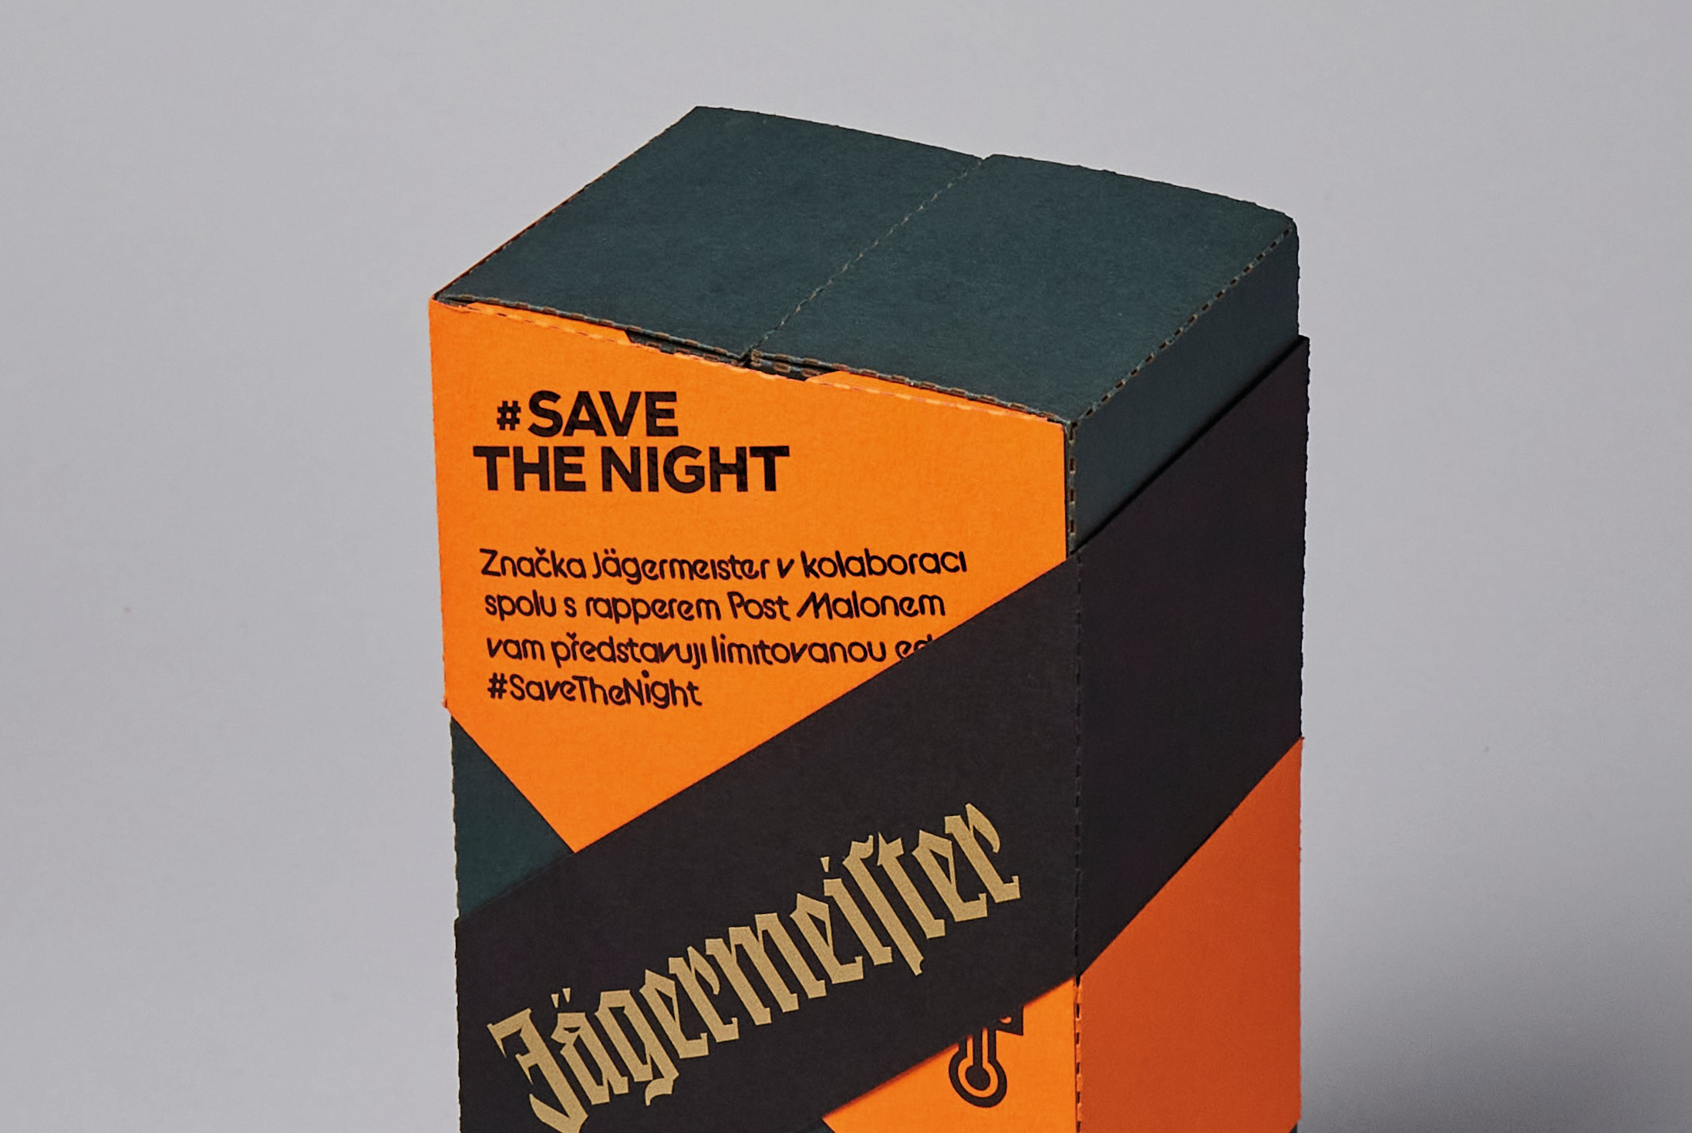
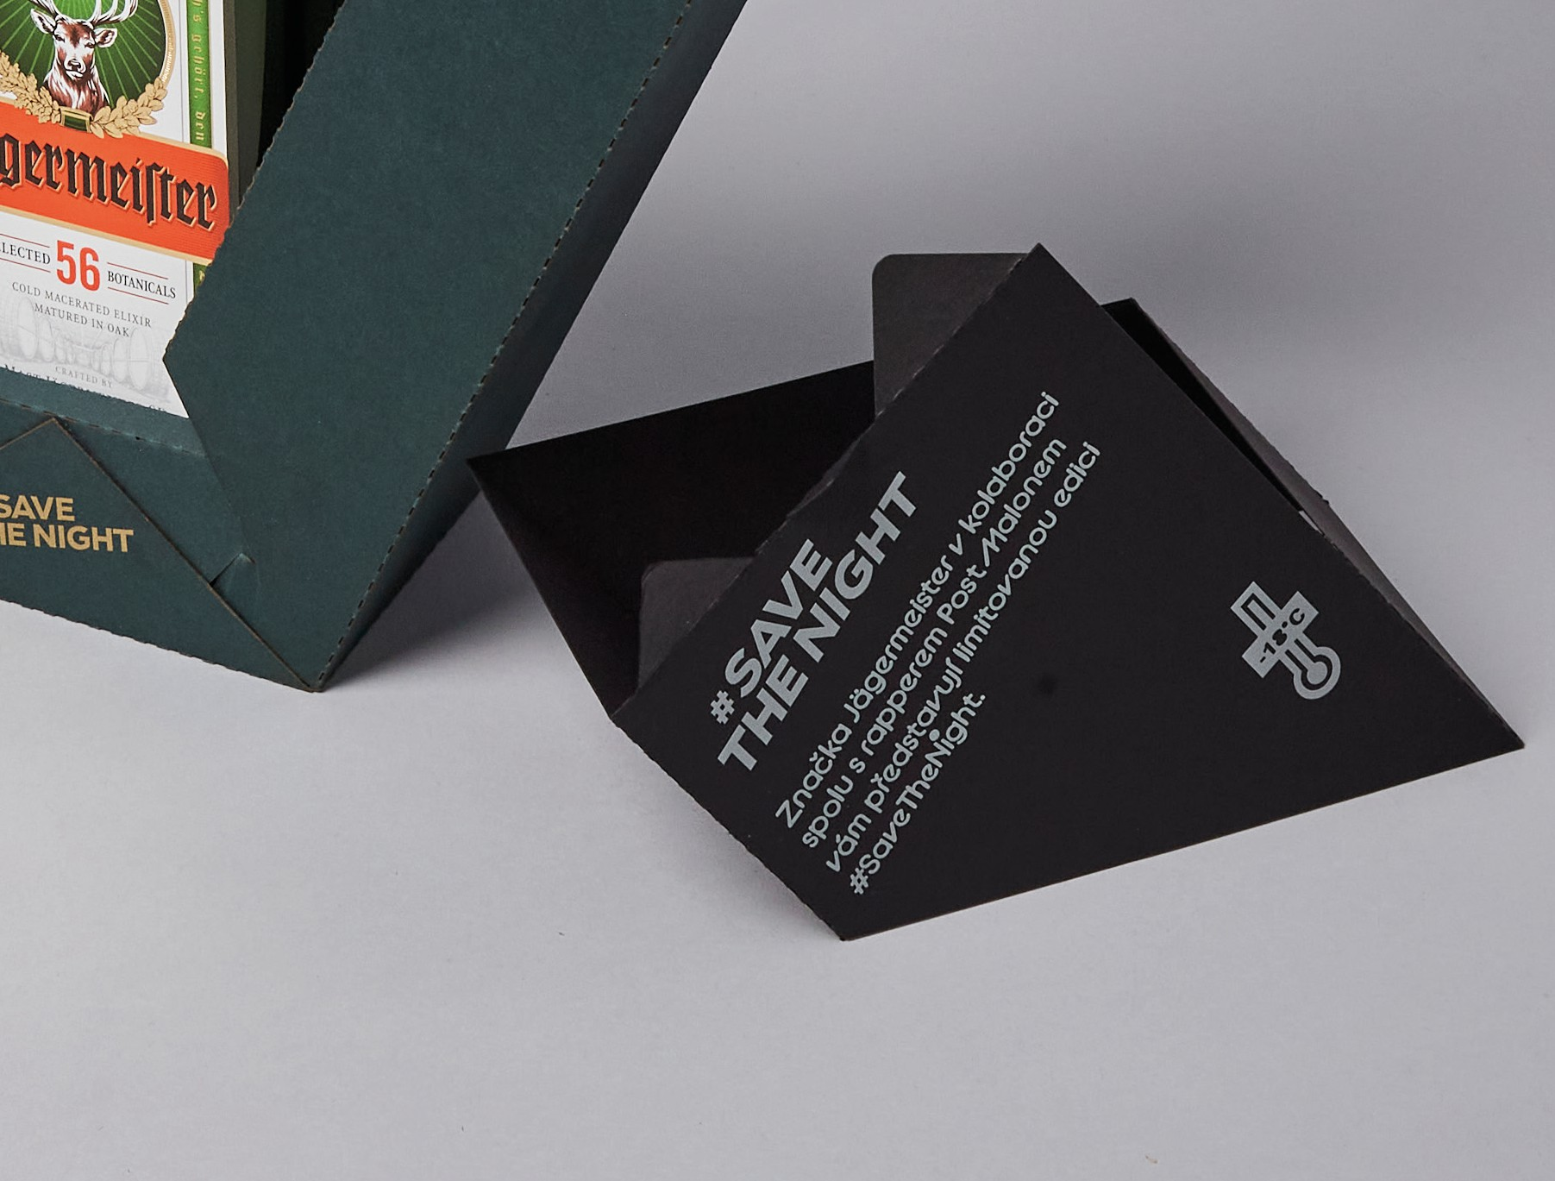

Structural design blueprint
Create a blueprint and insert it here. Important: Please use a vector format.
